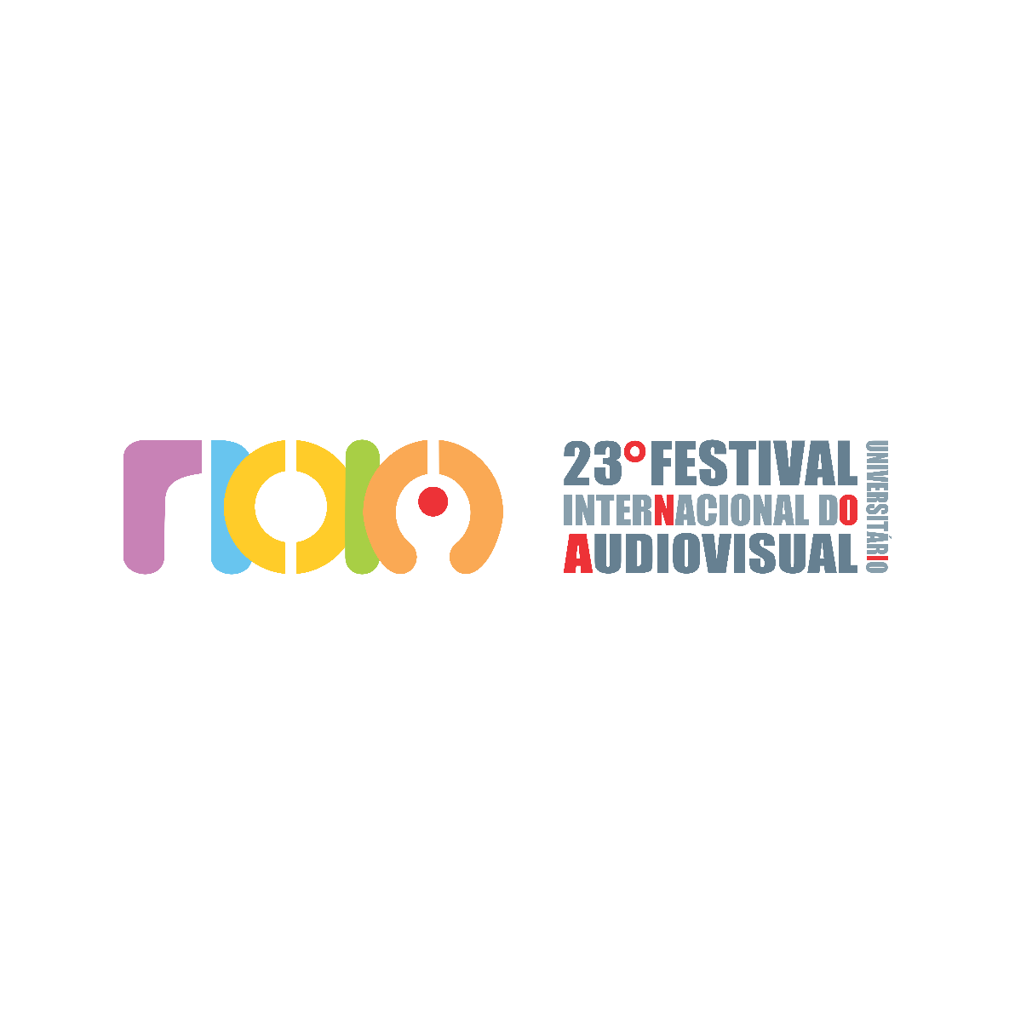

DECLARATION OF PARTICIPATION IN THE 23st NOIA - INTERNATIONAL UNIVERSITY AUDIOVISUAL FESTIVAL / TERM OF AUTHORIZATION OF USE OF IMAGE AND ASSIGNMENT OF COPYRIGHT

• WE AUTHORIZE THE DIRECTORS OF THE FESTIVAL NOIA, FREE OF CHARGE, TO DISPLAY THE IMAGE OF THE DIRECTOR AND OTHER MEMBERS, WHOSE NAMES APPEAR IN THE INFORMED TECHNICAL SHEET, WITH OR WITHOUT AUDIO, IN ANY AND ALL PUBLICITY OR JOURNALISTIC DISCLOSURE OF THE FESTIVAL (PHYSICAL OR VIRTUAL), IN THIS OR FUTURE EDITIONS.

• WE AUTHORIZE THE EXHIBITION OF THE SHORT ENROLLED IN THE ACTIVITIES RELATED TO THE FESTIVAL NOIA IN CHARACTER OF DISSEMINATION, BY ANY EXHIBITION PLATFORM - VIRTUAL, TELEVISION OR FACE-TO-FACE, IN THIS AND IN LATER EDITIONS, IN PUBLIC AND PRIVATE PLACES. THE AUTHORIZATION IS FOR AN INDEFINITE PERIOD AND THE FREE ASSIGNMENT OF PROPERTY RIGHTS IS FOR 70 YEARS, OBLIGING THE SUCCESSORS OF THE PARTIES TO ANY TITLE AND TIME.

• WE ASSUME THE RESPONSIBILITY TO RESPOND FULLY AND EXCLUSIVELY, INCLUDING IN RIGHT OF RETURN, TO ANY CLAIM OR DISPUTE RELATED TO LAGIAR OR OTHER COPYRIGHT INFRINGEMENTS;

• WE WILL CONSIDER VALID AND EFFECTIVE ALL COMMUNICATIONS THAT ARE MADE THROUGH THE DATA OF THE PERSON RESPONSIBLE FOR REGISTRATION, ASSUMING THE COMMITMENT TO KEEP THEM UPDATED, UNDER PENALTY OF, IN NOT DOING SO, WE DO NOT HAVE THE RIGHT TO ANY INDEMNIFICATION, PAYMENT OR CLAIM DUE TO NOT TAKING NOTICE OF COMMUNIQUÉS MADE THROUGH THE DATA INFORMED.

• THE FORO OF THE DISTRICT OF FORTALEZA-CE IS ELECTED FOR ALL PURPOSES.

DIRECTOR / RESPONSIBLE FOR THE FILM:
LOCATION (CITY/STATE):
NAME:
UTR (or other document identification):

DATE: _______/__________________/ 2025.

SIGNATURE:

